深 圳 大 学 实 验 报 告

课程编号： 2801000049

课程名称： 机器学习

实验项目名称： clustering

学院： 电子与信息工程学院

专业： 电子信息工程

指导教师： 麦晓春

报告人：卫宏林 学号： 2022300013 班级： 文华班

实验时间： 2024.5.24-2024.6.8

实验报告提交时间： 2024.6.8

教务部制
1. Experimental Purposes and Requirements
1. Load 5 datasets
- `noisy_circles.txt` (n_clusters=2)
- `noisy_moons.txt` (n_clusters=2)
- `blobs.txt` (n_clusters=3)
- `aniso.txt` (n_clusters=3)
- `no_structure.txt` (n_clusters=3)

2. Drawing scatterplots to visualize data sets

3. Use K-means Clustering on all the data sets separately, and visualize the clustering results

4. Use DBScan on all the data sets separately, adjust the parameter eps for different datasets, and visualize the clustering results

2. Experiment Contents and Process
2.1 Experiment 1
(1) Experimental Contents/Introduction
The basic idea of the K-means algorithm is to iteratively divide the data into K different clusters and minimize the sum of distances between each data point and its cluster's centroid (also known as the center or mean point).

Specifically, the K-means algorithm typically includes the following steps:
1. Firstly, randomly select K data points as initial cluster centroids.
2. Then, assign each data point to the nearest cluster based on the distance to each cluster centroid.
3. Next, recalculate the centroid of each cluster by taking the average of all data points within the cluster.
4. Repeat the assignment and update steps until some termination condition is met (such as cluster centroids no longer significantly changing or reaching a predefined number of iterations).
(2) Methods
1）Initialization: Select K initial cluster centers
At the beginning of the algorithm, K data points are randomly chosen as initial cluster centers. The selection of these initial cluster centers has a certain impact on the final clustering result. Therefore, in practical applications, some heuristic methods are usually adopted to choose better initial cluster centers, such as the K-means++ algorithm.
(2) Assignment: Assign each data point to the nearest cluster center
For each data point in the dataset, calculate its distance to each cluster center and assign it to the nearest cluster center. This step commonly uses the Euclidean distance as the distance measure, with the calculation formula as follows:
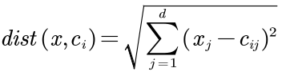
(3) Update: Recalculate the center of each cluster by computing the mean of all data points within the cluster.
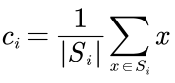
Iteration: Repeat allocation and update steps until the termination condition is met. The process involves continuously optimizing the clustering results by making objects within each cluster more cohesive and spreading objects across different clusters. When the termination condition is satisfied, the algorithm stops iterating and outputs the final clustering results. It is crucial to note that the K-means algorithm is highly sensitive to the initial selection of cluster centers and the setting of the number of clusters (K). Different initial cluster centers and K values can lead to entirely different clustering results. Therefore, in practical applications, it is typically necessary to consider the specific problem and data characteristics when selecting appropriate initial cluster centers and K values. Multiple runs of the algorithm may be required to obtain more stable results.
(3) Data Collection, Preprocessing and Analysis
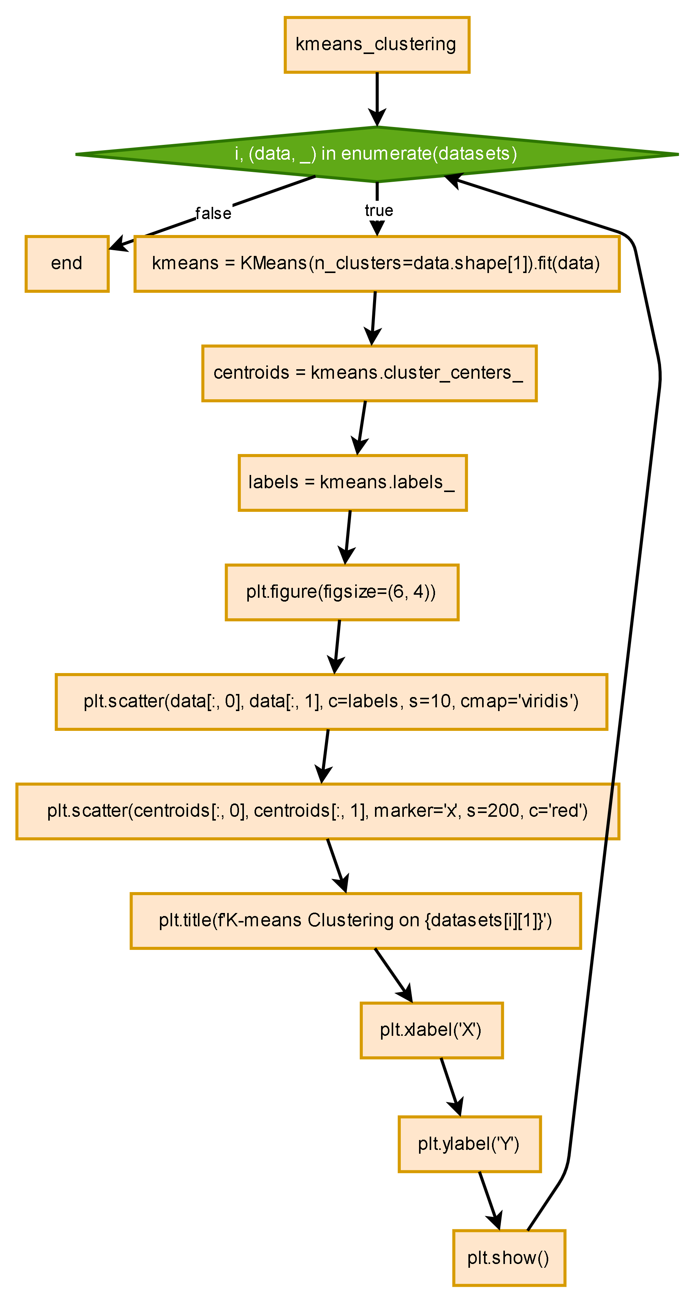

(4) Experimental Results and Analysis
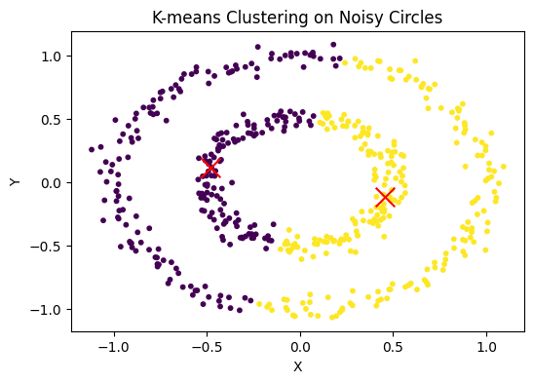

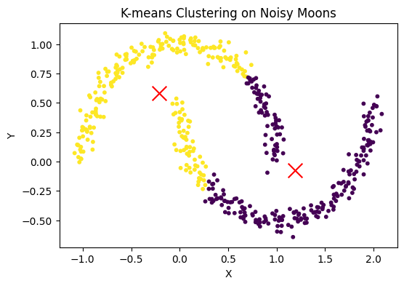

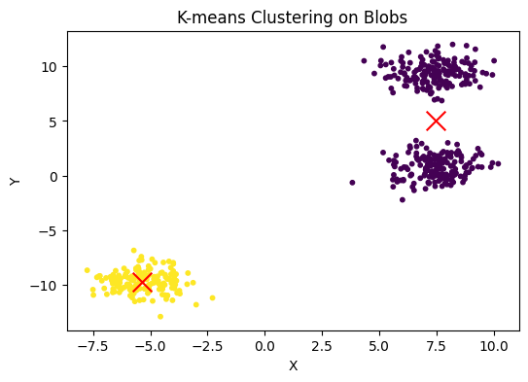

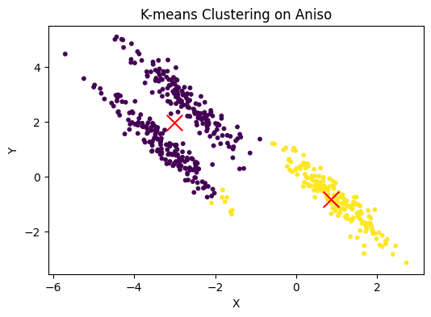

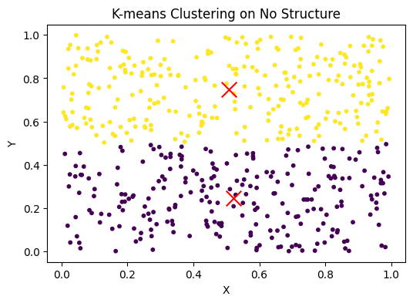

Analysis：
- Cluster Compactness and Separation:
  - Compactness (Intra-cluster Variance): K-means minimizes the sum of squared distances between points and their respective cluster centroids. After clustering, we can analyze the compactness of clusters by measuring the average distance of points to their cluster centroids. Lower intra-cluster variance indicates more compact clusters.
  - Separation (Inter-cluster Distance): Good clustering should also ensure that clusters are well-separated. This can be evaluated by measuring the distance between centroids of different clusters. Larger inter-cluster distances suggest that clusters are well-separated.
- Silhouette Score:
  - The silhouette score combines both the compactness and separation aspects of clustering into a single metric. It measures how similar a point is to its own cluster compared to other clusters. The score ranges from -1 to 1, where a high value indicates that points are well-matched to their own cluster and poorly matched to neighboring clusters. Analyzing the silhouette score helps to evaluate the quality of clustering and to identify if the chosen number of clusters (k) is appropriate.

2.1 Experiment 2
(1) Experimental Contents/Introduction
The DBSCAN algorithm mainly has two parameters:
- Eps: the radius of the neighborhood
- MinPts: the minimum number of points within the neighborhood to be considered a core point

### Eps-neighborhood of a point
The Eps-neighborhood of a point p, denoted as N$_\mathrm{Eps}$(p), is defined as the set of all points q in the dataset D such that the distance between p and q is less than or equal to Eps.

### Core points
A point is a core point if its Eps-neighborhood contains at least MinPts points.

### Directly density-reachable
A point p is directly density-reachable from a point q if:
1. p is within the Eps-neighborhood of q
2. The Eps-neighborhood of q contains at least MinPts points

### Density-reachable
A point p is density-reachable from a point q if there is a chain of points p1, p2, ..., pn, such that:
1. p1 = q
2. pn = p
3. Each point pi+1 is directly density-reachable from pi

### Density-connected
Two points p and q are density-connected if there is a point o such that both p and q are density-reachable from o.

### Cluster
For a dataset D, a cluster C is a subset of D that satisfies:
1. For any point p in C, any point q that is density-reachable from p is also in C
2. Any two points in C are density-connected

### Noise
Points that do not belong to any cluster are considered noise.

2) Methods
1) Define the neighborhood radius, Eps, and the minimum number of points required within this radius to form a core point, MinPts.
2) Start with an arbitrary point p, mark it as "visited," and check if it is a core point (i.e., if there are at least MinPts points within its Eps neighborhood). If p is not a core point, mark it as noise. Otherwise, create a new cluster C for p and add all points within p's Eps neighborhood to a candidate set N.
3) Iteratively add points from N that do not belong to any other cluster into C. During this process, for each point p' in N that is marked as "unvisited," mark p' as "visited" and check its Eps neighborhood. If p' is also a core point, add all points in p's Eps neighborhood to N. Continue adding points to C until C can no longer be expanded, i.e., until N is empty. At this point, cluster C is fully formed.
4) Randomly select the next unvisited point from the remaining points and repeat step 3 until all points have been visited.
(3) Data Collection, Preprocessing and Analysis
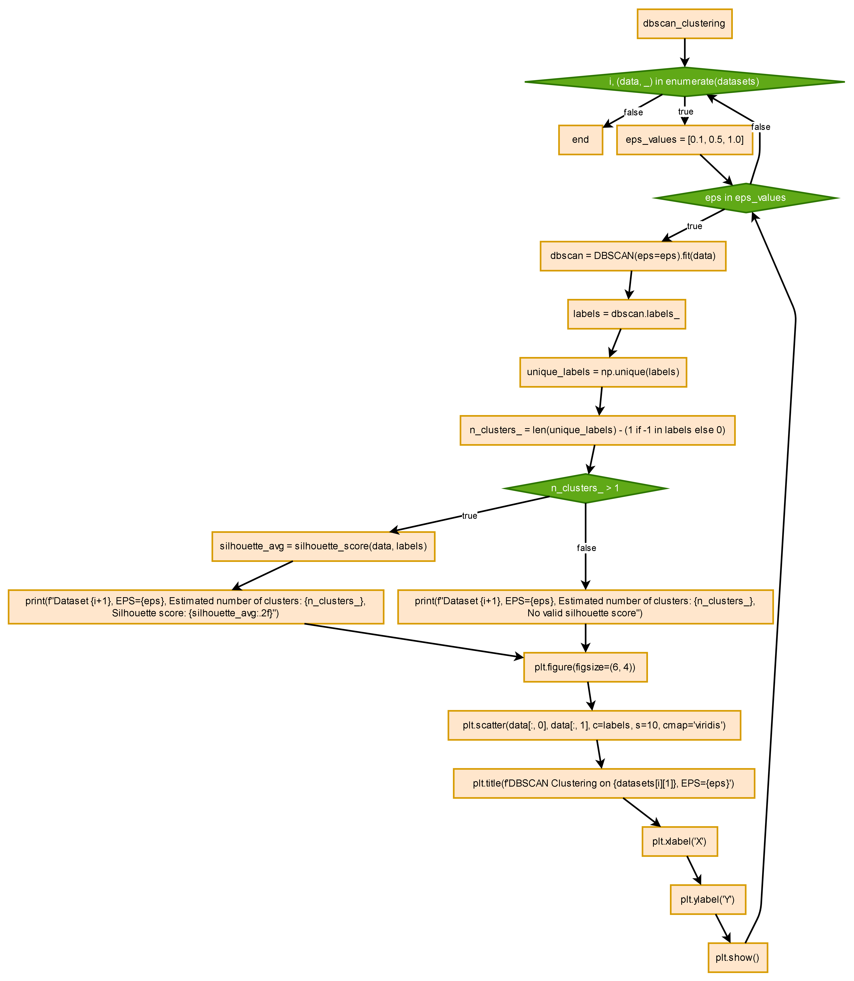

(4) Experimental Results and Analysis
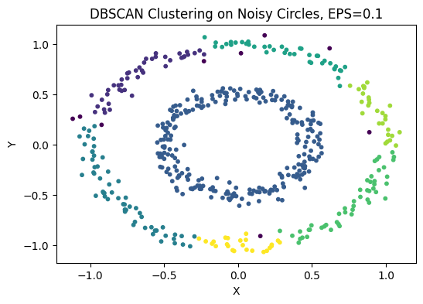
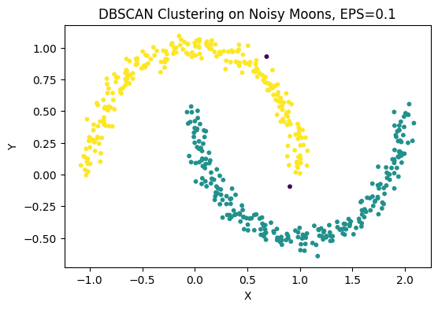

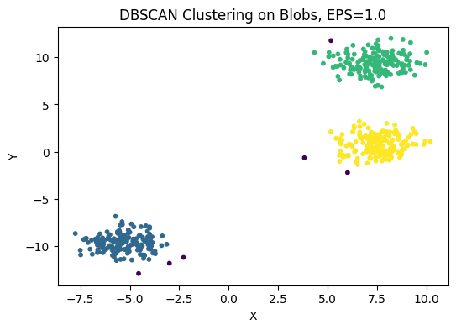

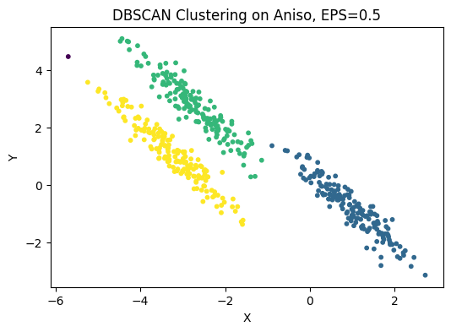

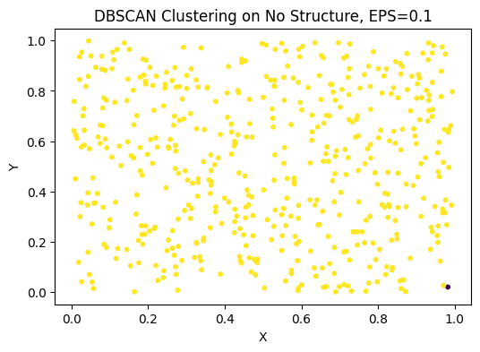

Analysis：
- Core, Border, and Noise Points:
  - Core Points: Points with at least MinPts neighbors within a radius Eps. Core points form the dense regions of clusters.
  - Border Points: Points that have fewer than MinPts neighbors within Eps but are within the Eps radius of a core point. They are on the edges of clusters.
  - Noise Points: Points that do not belong to any cluster. Identifying and analyzing noise points can help understand the presence of outliers in the dataset. A high number of noise points might indicate that Eps or MinPts are not optimally set or that the data contains many outliers.
- Cluster Density and Shape:
  - Density-based Clusters: Unlike K-means, DBSCAN can form clusters of arbitrary shape. By analyzing the resulting clusters, we can evaluate how well the algorithm has identified dense regions and handled varying cluster shapes. This is particularly useful for datasets where clusters are not spherical or have irregular shapes.
  - Parameter Sensitivity: DBSCAN’s performance heavily depends on the choice of Eps and MinPts. Analyzing the clustering results for different parameter settings can help to understand the sensitivity and robustness of the algorithm. This can be done through a parameter sweep, where multiple combinations of Eps and MinPts are tested to find the best clustering result.

3. Discussion and Conclusions
(1)If the distribution of data characteristic, presents non-linear separate on DBSCAN cluster method may be suitable to correctly classify. If the distribution of data presents linear separation characteristic and two
(2)potential class data not distribute closely, k-means method and DBSCAN cluster method are all suitable to correctly classify. Otherwise, DBSCAN cluster method may be suitable to correctly classify. We can adjust the parameter ofk-means clustering and DBSCAN method to
(3)achieve 'correctly’classify for the random distributed data.

Appendix
import numpy as np
import matplotlib.pyplot as plt
from sklearn.datasets import make_moons, make_circles, make_blobs
from sklearn.cluster import KMeans, DBSCAN
from sklearn.metrics import silhouette_score

# Function to load datasets
def load_datasets():
datasets = []
noisy_circles = np.loadtxt('noisy_circles.txt')
noisy_moons = np.loadtxt('noisy_moons.txt')
blobs = np.loadtxt('blobs.txt')
aniso = np.loadtxt('aniso.txt')
no_structure = np.loadtxt('no_structure.txt')
datasets.append((noisy_circles, 'Noisy Circles'))
datasets.append((noisy_moons, 'Noisy Moons'))
datasets.append((blobs, 'Blobs'))
datasets.append((aniso, 'Aniso'))
datasets.append((no_structure, 'No Structure'))
return datasets

# Function to draw scatterplots
def draw_scatterplots(datasets):
for i, (data, title) in enumerate(datasets):
plt.figure(figsize=(6, 4))
plt.scatter(data[:, 0], data[:, 1], s=10)
plt.title(title)
plt.xlabel('X')
plt.ylabel('Y')
plt.show()

# Function to perform K-means clustering and visualize results
def kmeans_clustering(datasets):
for i, (data, _) in enumerate(datasets):
kmeans = KMeans(n_clusters=data.shape[1]).fit(data)
centroids = kmeans.cluster_centers_
labels = kmeans.labels_
plt.figure(figsize=(6, 4))
plt.scatter(data[:, 0], data[:, 1], c=labels, s=10, cmap='viridis')
plt.scatter(centroids[:, 0], centroids[:, 1], marker='x', s=200, c='red')
plt.title(f'K-means Clustering on {datasets[i][1]}')
plt.xlabel('X')
plt.ylabel('Y')
plt.show()

# Function to perform DBSCAN clustering and visualize results
def dbscan_clustering(datasets):
for i, (data, _) in enumerate(datasets):
eps_values = [0.1, 0.5, 1.0] # Adjust eps values for different datasets
for eps in eps_values:
dbscan = DBSCAN(eps=eps).fit(data)
labels = dbscan.labels_
unique_labels = np.unique(labels)
n_clusters_ = len(unique_labels) - (1 if -1 in labels else 0)
if n_clusters_ > 1: # Check if there's more than one cluster
silhouette_avg = silhouette_score(data, labels)
print(f"Dataset {i+1}, EPS={eps}, Estimated number of clusters: {n_clusters_}, Silhouette score: {silhouette_avg:.2f}")
else:
print(f"Dataset {i+1}, EPS={eps}, Estimated number of clusters: {n_clusters_}, No valid silhouette score")
plt.figure(figsize=(6, 4))
plt.scatter(data[:, 0], data[:, 1], c=labels, s=10, cmap='viridis')
plt.title(f'DBSCAN Clustering on {datasets[i][1]}, EPS={eps}')
plt.xlabel('X')
plt.ylabel('Y')
plt.show()

# Main function
def main():
datasets = load_datasets()
draw_scatterplots(datasets)
kmeans_clustering(datasets)
dbscan_clustering(datasets)

if __name__ == "__main__":
main()

深圳大学学生实验报告用纸

指导教师批阅意见：

成绩评定：

指导教师签字：
年 月 日
备注：
注：1、报告内的项目或内容设置，可根据实际情况加以调整和补充。
2、教师批改学生实验报告时间应在学生提交实验报告时间后10日内。

